Experiment No. 9
Support Vector Machines

Experiment No. 9.1
Classification using Support Vector Machine (SVM)

1. Aim
To implement a classification model using Support Vector Machine (SVM) and analyze support vectors.

2. Objectives
To understand the concept of Support Vector Machine.
To study how SVM finds optimal decision boundaries.
To build an SVM classification model.
To identify support vectors and their role.
To analyze model attributes such as support vectors and their indices.

3. Software Required
Python 3.x
Jupyter Notebook / Google Colab / Anaconda
Scikit-learn Library

4. Introduction
Support Vector Machine (SVM) is a supervised machine learning algorithm used for classification and regression tasks.
SVM works by finding the optimal hyperplane that separates data points into different classes with maximum margin.

Applications of SVM include:
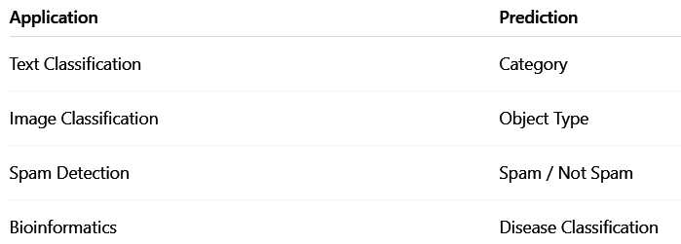

5. SVM Model

SVM aims to find the hyperplane that maximizes the margin between classes.
Decision boundary equation:
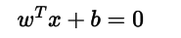

Where:
w = weight vector
x = input feature vector
b = bias
Support vectors are the data points closest to the hyperplane and determine its position.

6. Steps in Building an SVM Model
Import required libraries
Define dataset
Train SVM model
Predict class labels
Extract support vectors
Analyze model attributes
7. Dataset Description
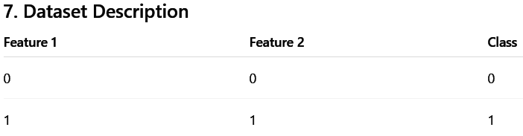
Class is the dependent variable
8. Dataset Characteristics
Total number of records: 2
Number of input features: 2
Target variable: Binary class (0 or 1)
Type of problem: Classification
9. Learning Objective
To understand how SVM identifies support vectors and constructs an optimal separating hyperplane.

10. Program
import numpy as np
from sklearn import svm

X = np.array([
[0, 0],
[1, 0],
[0, 1],
[1, 1]
])

y = np.array([0, 1, 0, 1])
model = svm.SVC(kernel='linear')
model.fit(X, y)
prediction = model.predict([[1, 0]])
print("Predicted Class:", prediction)
print("\nSupport Vectors:\n", model.support_vectors_)
print("\nIndices of Support Vectors:\n", model.support_)
print("\nNumber of Support Vectors:\n", model.n_support_)

11. Output
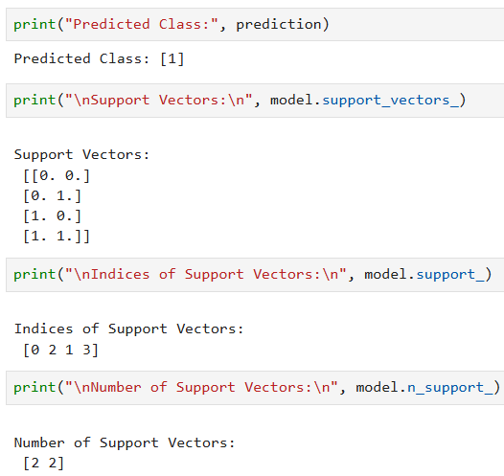

12. Output Interpretation
- The SVM model correctly classified the input data.
- Support vectors are the closest data points to the hyperplane.
- support_ shows the indices of support vectors.
- n_support_ displays the number of support vectors in each class.

13. Result
The Support Vector Machine classifier was successfully implemented and support vectors were identified correctly.

14. Conclusion
SVM is a powerful classification algorithm that constructs an optimal hyperplane using support vectors. It performs well in high-dimensional spaces and provides robust classification performance.

15. Viva Questions & Answers

1. What is Support Vector Machine?
A supervised learning algorithm used for classification and regression.

2. What is a hyperplane?
A decision boundary that separates classes.

3. What are support vectors?
Data points closest to the hyperplane.

4. What is margin in SVM?
The distance between the hyperplane and support vectors.

5. What is the role of kernel in SVM?
Kernels help classify non-linear data.

6. Difference between linear and non-linear SVM?
Linear SVM | Non-linear SVM
Straight boundary | Curved boundary
Uses linear kernel | Uses kernels like RBF

7. What is overfitting in SVM?
When the model performs well on training data but poorly on new data.

8. What is the significance of support vectors?
They determine the position of the hyperplane.

9. What is a soft margin?
Allows some misclassification to improve generalization.

10. Where is SVM used in real-world applications?
Image recognition, text classification, spam filtering, and medical diagnosis.

Experiment No. 9.2

Case Study: Linear SVM Classification using Social Network Ads Dataset

1. Aim
To implement a Linear Support Vector Machine (SVM) model on a real-world dataset and evaluate its performance using classification metrics.

2. Objectives
- To understand the concept of Support Vector Machine.
- To apply Linear SVM for classification problems.
- To perform feature scaling for SVM.
- To evaluate the model using confusion matrix and performance metrics.
- To compute accuracy, precision, recall, and F1-score.

3. Software Required
- Python 3.x
- Jupyter Notebook / Google Colab / Anaconda
- Pandas Library
- NumPy Library
- Scikit-learn Library
- Matplotlib Library

4. Introduction
Support Vector Machine (SVM) is a supervised machine learning algorithm widely used for classification tasks. In this case study, a Linear SVM model is applied to predict whether a customer will purchase a product based on Age and Estimated Salary. SVM constructs an optimal hyperplane that separates classes with maximum margin, resulting in strong generalization performance.

5. SVM Model
The linear decision boundary of SVM is defined as:
w⋅x+b=0w \cdot x + b = 0w⋅x+b=0
Where:
- w → Weight vector
- x → Feature vector
- b → Bias term
SVM maximizes the margin between two classes using support vectors, which are the most influential data points.

6. Steps in Building the Model
- Import required libraries
- Load dataset
- Select features and target variable
- Perform train-test split
- Apply feature scaling
- Train Linear SVM model
- Predict results
- Evaluate performance

7. Dataset Description
Dataset Used: Social_Network_Ads.csv
- Features: Age, Estimated Salary
- Target Variable: Purchased

8. Dataset Characteristics
- Type of Problem: Classification
- Input Features: 2
- Output Variable: Purchased
- Dataset Type: Real-world dataset

9. Learning Objective
To understand how Linear SVM classifies customer purchase behavior using an optimal separating hyperplane and evaluates performance using classification metrics.

10. Program
import pandas as pd
import numpy as np
import matplotlib.pyplot as plt

from sklearn.model_selection import train_test_split
from sklearn.preprocessing import StandardScaler
from sklearn.svm import SVC
from sklearn.metrics import confusion_matrix
from sklearn.metrics import accuracy_score
from sklearn.metrics import classification_report
dataset = pd.read_csv("Social_Network_Ads.csv")
X = dataset[['Age', 'EstimatedSalary']]
y = dataset['Purchased']
X_train, X_test, y_train, y_test = train_test_split(
X, y, test_size=0.25, random_state=0
)

sc = StandardScaler()

X_train = sc.fit_transform(X_train)
X_test = sc.transform(X_test)

model = SVC(kernel='linear', random_state=0)
model.fit(X_train, y_train)
y_pred = model.predict(X_test)
cm = confusion_matrix(y_test, y_pred)
accuracy = accuracy_score(y_test, y_pred)

print("Confusion Matrix:\n", cm)
print("\nAccuracy:", accuracy)

print("\nClassification Report:\n",
classification_report(y_test, y_pred))
Output:
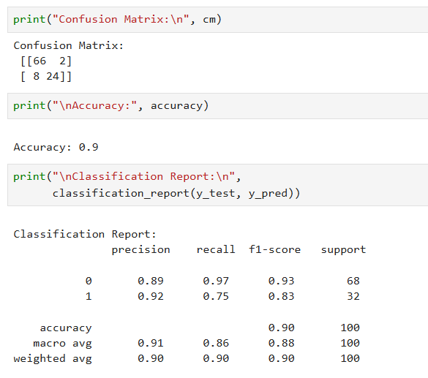

12. Conclusion
Linear SVM is an effective classification algorithm that identifies an optimal separating hyperplane between classes. After applying feature scaling, the model performs efficiently on real-world datasets and produces reliable classification results with good accuracy and balanced performance metrics.

Viva Questions and Answers

1. What is Support Vector Machine?
SVM is a supervised learning algorithm used for classification and regression that finds an optimal separating hyperplane.

2. What is a linear kernel in SVM?
A linear kernel creates a straight-line decision boundary between classes.

3. Why is feature scaling important in SVM?
Feature scaling ensures all features contribute equally and improves model performance.

4. What is a hyperplane?
A hyperplane is a boundary that separates data into different classes.

5. What are support vectors?
Support vectors are the closest data points to the decision boundary that influence the hyperplane.

6. What is margin in SVM?
Margin is the distance between the hyperplane and nearest data points of both classes.

7. What is confusion matrix?
A confusion matrix shows correct and incorrect predictions of a classification model.

8. What are precision, recall, and F1-score?
- Precision measures prediction correctness.
- Recall measures detection ability.
- F1-score balances both precision and recall.

9. What is overfitting in SVM?
Overfitting occurs when the model learns noise instead of general patterns.

10. Where is SVM used in real-world applications?
SVM is used in spam filtering, face recognition, medical diagnosis, text classification, and fraud detection.

Experiment No. 9.3

Non-Linear SVM Classification using RBF Kernel

1. Aim
To implement a Non-Linear Support Vector Machine (SVM) using the RBF kernel and evaluate its performance on a non-linearly separable dataset.

2. Objectives
- To understand non-linear classification using SVM.
- To study the role of kernel functions in SVM.
- To implement SVM with RBF (Radial Basis Function) kernel.
- To evaluate the model using accuracy, precision, recall, and F1-score.
- To analyze performance on non-linearly separable data.

3. Software Required
- Python 3.x
- Jupyter Notebook / Google Colab / Anaconda
- NumPy Library
- Scikit-learn Library
- Matplotlib Library

4. Introduction
In many real-world machine learning problems, data cannot be separated using a straight line or linear boundary. Support Vector Machine overcomes this limitation using kernel functions, which transform input data into a higher-dimensional feature space where linear separation becomes possible.
The Radial Basis Function (RBF) kernel is one of the most commonly used kernels for handling complex and non-linear datasets.

5. SVM with RBF Kernel
The RBF kernel is defined as:
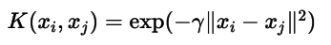
Where:
- γ (gamma) controls influence of training samples.
- Smaller γ → smoother boundary.
- Larger γ → complex boundary.
The kernel enables SVM to create flexible non-linear decision boundaries.

6. Steps in Building the Model
- Import required libraries
- Generate non-linear dataset
- Split dataset into training and testing sets
- Train SVM model using RBF kernel
- Predict test results
- Evaluate model performance

7. Dataset Description
- A synthetic dataset is generated using circular patterns.
- The dataset is non-linearly separable.
Dataset is generated using:
make_circles()

8. Dataset Characteristics
- Number of Samples: 500
- Number of Features: 2
- Type of Problem: Non-linear Classification
- Dataset Type: Synthetic

9. Learning Objective
To understand how SVM with RBF kernel handles complex non-linear decision boundaries effectively by transforming data into higher-dimensional space

10. Program
import numpy as np
import matplotlib.pyplot as plt
from sklearn.datasets import make_circles
from sklearn.model_selection import train_test_split
from sklearn.preprocessing import StandardScaler
from sklearn.svm import SVC
from sklearn.metrics import accuracy_score, classification_report, confusion_matrix

X, y = make_circles(n_samples=500, noise=0.1, factor=0.5, random_state=0)

X_train, X_test, y_train, y_test = train_test_split(
X, y, test_size=0.25, random_state=0
)
sc = StandardScaler()
X_train = sc.fit_transform(X_train)
X_test = sc.transform(X_test)

model = SVC(kernel='rbf', gamma='scale', C=1)
model.fit(X_train, y_train)
y_pred = model.predict(X_test)

print("Confusion Matrix:\n", confusion_matrix(y_test, y_pred))
print("\nAccuracy:", accuracy_score(y_test, y_pred))
print("\nClassification Report:\n", classification_report(y_test, y_pred))

Output:
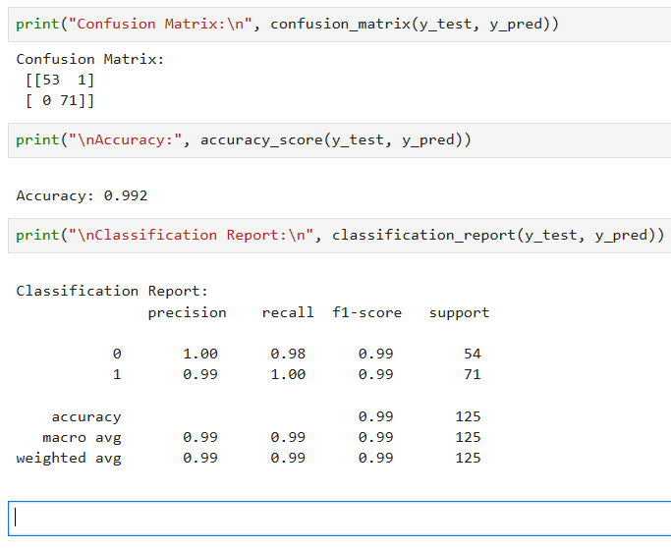

12. Conclusion
Non-linear SVM using the RBF kernel effectively handles datasets that cannot be separated using linear boundaries. By transforming data into higher dimensions, the model creates flexible decision boundaries and achieves high classification accuracy for complex datasets.

13. Viva Questions

1. What is non-linear classification?
Classification where data cannot be separated using a straight line or linear boundary.

2. What is kernel trick in SVM?
Kernel trick maps data into higher dimensions without explicitly computing transformations.

3. What is RBF kernel?
RBF kernel measures similarity between data points using distance and enables non-linear classification.

4. What is the role of gamma in RBF kernel?
Gamma controls the influence range of a training sample on decision boundary formation.

5. What is parameter C in SVM?
C controls trade-off between maximizing margin and minimizing classification error.

6. Why linear SVM fails on non-linear data?
Because linear SVM can only create straight decision boundaries.

7. What is decision boundary?
A boundary separating different classes in feature space.

8. What is overfitting in SVM?
When model fits training data too closely and performs poorly on unseen data.

9. Difference between linear and RBF kernel?
Linear kernel creates straight boundaries, while RBF kernel creates curved non-linear boundaries.

10. Where is non-linear SVM used?
Used in image recognition, bioinformatics, handwriting recognition, and pattern classification.

Experiment No. 9.4

Multiclass Classification using SVM (One-vs-One Strategy)

1. Aim
To implement multiclass classification using Support Vector Machine (SVM) and evaluate its performance using the One-vs-One strategy.

2. Objectives
- To understand multiclass classification in machine learning.
- To study SVM strategies for handling multiple classes.
- To implement SVM using One-vs-One (OvO) strategy.
- To perform feature scaling for SVM.
- To evaluate model performance using accuracy and confusion matrix.

3. Software Required
- Python 3.x
- Jupyter Notebook / Google Colab / Anaconda
- Scikit-learn Library
- NumPy Library

4. Introduction
Support Vector Machine (SVM) is primarily a binary classification algorithm. However, many real-world problems involve more than two classes.
SVM can be extended for multiclass problems using strategies such as:
- One-vs-One (OvO)
- One-vs-Rest (OvR)
In the One-vs-One strategy, a separate classifier is trained for every pair of classes. Each classifier votes for a class, and the class receiving the majority votes becomes the final prediction.

5. Multiclass SVM Model
In One-vs-One strategy, if the number of classes is k, then the number of classifiers created is:
k(k−1)2\frac{k(k-1)}{2}2k(k−1)​
Each classifier distinguishes between two classes, and the final class label is determined using majority voting.

6. Steps in Building the Model
- Import required libraries
- Load dataset
- Split dataset into training and testing sets
- Apply feature scaling
- Train SVM model using OvO strategy
- Predict test results
- Evaluate performance

7. Dataset Description
The Wine Dataset is used for multiclass classification.
- Number of Classes: 3
- Features: Multiple numerical attributes

8. Dataset Characteristics
- Number of Samples: 178
- Number of Features: 13
- Number of Classes: 3
- Type of Problem: Multiclass Classification

9. Learning Objective
To understand how SVM can perform multiclass classification using the One-vs-One strategy and evaluate its prediction performance.

10. Program
import numpy as np
from sklearn.datasets import load_wine
from sklearn.model_selection import train_test_split
from sklearn.preprocessing import StandardScaler
from sklearn.svm import SVC
from sklearn.metrics import accuracy_score, confusion_matrix, classification_report

data = load_wine()
X = data.data
y = data.target

X_train, X_test, y_train, y_test = train_test_split(
X, y, test_size=0.25, random_state=0
)

sc = StandardScaler()
X_train = sc.fit_transform(X_train)
X_test = sc.transform(X_test)
model = SVC(kernel='rbf', decision_function_shape='ovo')

model.fit(X_train, y_train)

y_pred = model.predict(X_test)

print("Confusion Matrix:\n", confusion_matrix(y_test, y_pred))
print("\nAccuracy:", accuracy_score(y_test, y_pred))
print("\nClassification Report:\n", classification_report(y_test, y_pred))

Output:
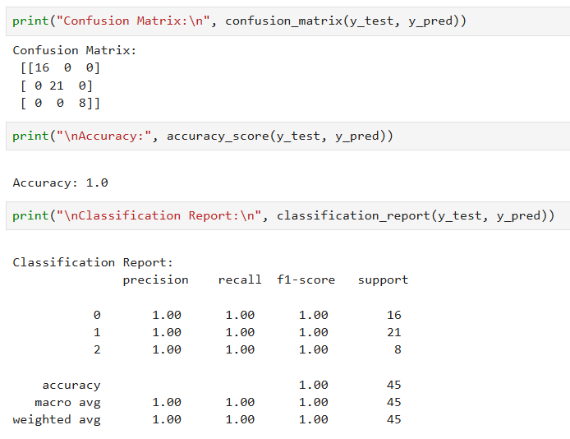

12. Conclusion
Support Vector Machine successfully performs multiclass classification using the One-vs-One strategy. By combining multiple binary classifiers and applying majority voting, the model achieves high accuracy and effective class separation.

13. Viva Questions

1. What is multiclass classification?
Multiclass classification involves predicting one label among more than two possible classes.

2. Why is SVM originally a binary classifier?
SVM is designed to separate only two classes using an optimal hyperplane.

3. What is One-vs-One strategy?
OvO trains a separate classifier for every pair of classes and uses voting for prediction.

4. What is One-vs-Rest strategy?
OvR trains one classifier per class against all remaining classes.

5. How many classifiers are created in OvO?
k(k−1)2\frac{k(k-1)}{2}2k(k−1)​
For k classes, this many classifiers are created.

6. Why is feature scaling important in SVM?
SVM depends on distance calculations, so scaling ensures equal feature contribution.

7. What is decision_function_shape in SVM?
It specifies whether multiclass classification uses OvO or OvR strategy.

8. What is confusion matrix?
A table showing correct and incorrect predictions for each class.

9. What are advantages of OvO strategy?
It provides better accuracy and works well when number of classes is moderate.

10. Where is multiclass SVM used?
Used in image recognition, handwriting recognition, medical diagnosis, and object classification.

Experiment 9.5

Non-Linear SVM using Pipeline and Hyperparameter Tuning (GridSearchCV)

1. Aim
To implement a non-linear SVM model using a pipeline and optimize its performance using GridSearchCV for hyperparameter tuning.

2. Objectives
- To understand the concept of pipelines in machine learning.
- To implement SVM with RBF kernel for non-linear classification.
- To perform feature scaling using StandardScaler.
- To apply hyperparameter tuning using GridSearchCV.
- To identify optimal parameters for improved model performance.

3. Software Required
- Python 3.x
- Jupyter Notebook / Google Colab / Anaconda
- Scikit-learn Library

4. Introduction
Machine learning workflows often involve multiple steps such as preprocessing, scaling, and model training. A pipeline combines these steps into a single workflow, ensuring consistency and reducing errors.
Support Vector Machine (SVM) with RBF kernel is powerful for non-linear classification problems. However, its performance depends strongly on important hyperparameters:
- C – Regularization parameter
- Gamma – Kernel coefficient
GridSearchCV automatically tests multiple parameter combinations using cross-validation to select the best-performing model.

5. SVM with Hyperparameter Tuning
The RBF kernel transforms data into higher-dimensional space:
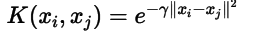
GridSearchCV evaluates different values of C and gamma to find the optimal hyperparameters that maximize model performance.

6. Steps in Building the Model
- Import required libraries
- Load dataset
- Split dataset into training and testing sets
- Create pipeline (Scaling + SVM)
- Define parameter grid
- Apply GridSearchCV
- Train model
- Evaluate best model

7. Dataset Description
The Iris Dataset is used for classification.

Dataset Attributes
Attribute | Description
Sepal Length | Length of sepal
Sepal Width | Width of sepal
Petal Length | Length of petal
Petal Width | Width of petal
Target | Species (3 classes)
The dataset table is shown on page 3 of the uploaded document.

8. Dataset Characteristics
- Number of Samples: 150
- Number of Features: 4
- Number of Classes: 3
- Type of Problem: Multiclass Classification

9. Learning Objective
To understand how pipelines and GridSearchCV automate preprocessing and hyperparameter tuning to improve SVM model performance.

10. Program
from sklearn.datasets import load_iris
from sklearn.model_selection import train_test_split, GridSearchCV
from sklearn.pipeline import Pipeline
from sklearn.preprocessing import StandardScaler
from sklearn.svm import SVC
from sklearn.metrics import accuracy_score, classification_report

data = load_iris()
X = data.data
y = data.target

X_train, X_test, y_train, y_test = train_test_split(
X, y, test_size=0.25, random_state=42
)
pipeline = Pipeline([
('scaler', StandardScaler()),
('svm', SVC(kernel='rbf'))
])

param_grid = {
'svm__C': [0.1, 1, 10, 100],
'svm__gamma': [0.01, 0.1, 1, 10]
}

grid = GridSearchCV(
pipeline,
param_grid,
cv=5,
scoring='accuracy'
)

grid.fit(X_train, y_train)
print("Best Parameters:", grid.best_params_)
y_pred = grid.predict(X_test)

print("Accuracy:", accuracy_score(y_test, y_pred))
print("\nClassification Report:\n", classification_report(y_test, y_pred))
Output:
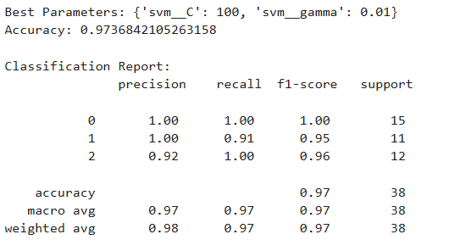

12. Conclusion
Using pipelines and GridSearchCV simplifies machine learning workflows by integrating preprocessing and model training into a single process. Hyperparameter tuning helps identify optimal SVM parameters, improving accuracy and generalization while reducing overfitting.

13. Viva Questions

1. What is a pipeline in machine learning?
A pipeline combines preprocessing and model training steps into a single workflow.

2. Why is StandardScaler used in SVM?
SVM relies on distance calculations, so scaling ensures equal feature contribution.

3. What is GridSearchCV?
It is a technique used to find the best hyperparameters using cross-validation.

4. What is cross-validation?
A method of evaluating model performance using multiple train-test splits.

5. What is parameter tuning?
The process of selecting optimal hyperparameter values for a model.

6. What is the role of C in SVM?
It controls the trade-off between margin size and classification error.

7. What is gamma in RBF kernel?
Gamma determines how far the influence of a training sample reaches.

8. Why use pipeline instead of separate steps?
It avoids data leakage and ensures consistent preprocessing.

9. What is overfitting in SVM?
When the model learns noise instead of general patterns.

10. What are advantages of GridSearchCV?
Automatic parameter selection, improved accuracy, and reliable model evaluation.

